Task 3.1

System description:
The system is a light monitor to detect sunlight for a home terrarium using an Arduino based microcontroller with a BH1750 ambient light sensor. The Arduino reads the lux values every 5 seconds and publishes it to a HiveMQ MQTT cloud broker. Node red then subscribes to the broker receiving data and handling notifications based on light triggers.
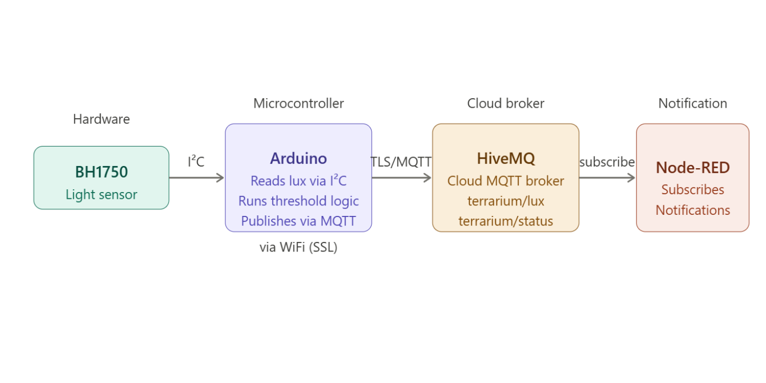

Trigger mechanism:
The trigger is handled locally in the publish topic function which determins whether the light threshold has been reached or not. This means a notification is only sent after a state has been changed.
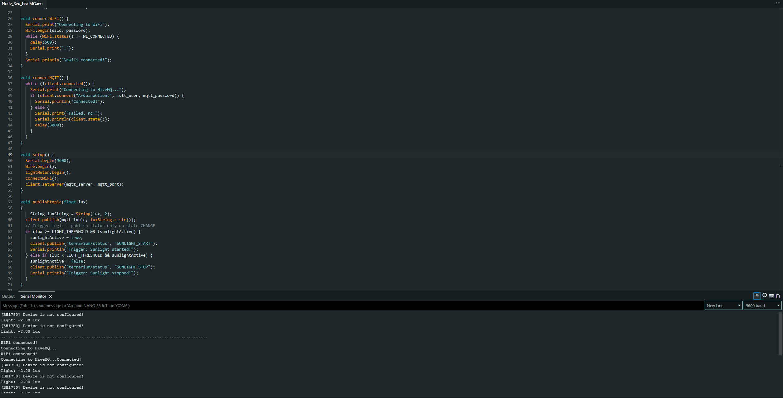

- If light changes above or below light threshold sunlightactive Boolean state is changed.
- After a state change, a notification is published to MQTT broker. This is to prevent a data flood

Notification mechanism:
The e-mail notification is handled by the NODE-RED which subscribes to the terrarium/status MQTT topic. It will receive a SUNLIGHT_START or SUNLIGHT_STOP message from the broker. After a message has been read it will check the content of the message and send the relevant email.

Setup:
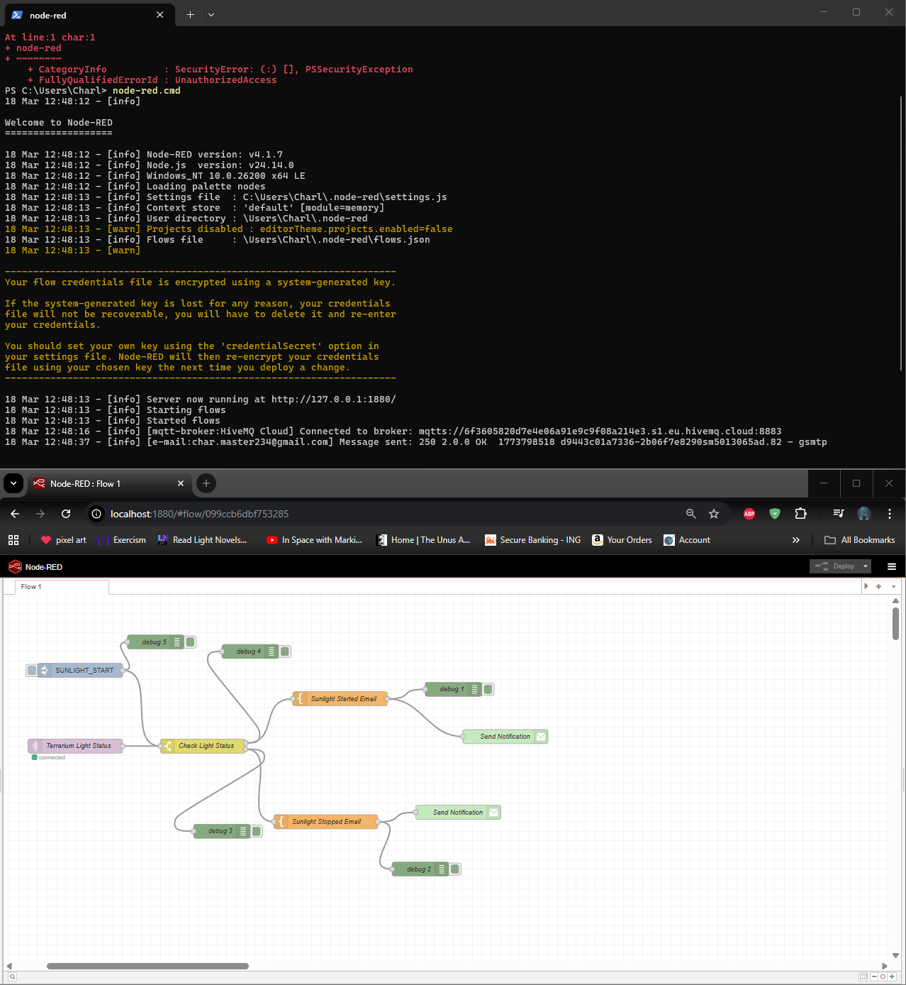
NODE-RED setup

The NODE-RED setup handles the email logic of the system by routing a switch node to a JSON node holding the email information which is subsequently sent to the email node which sends the email.
HiveMQ and Arduino setup:
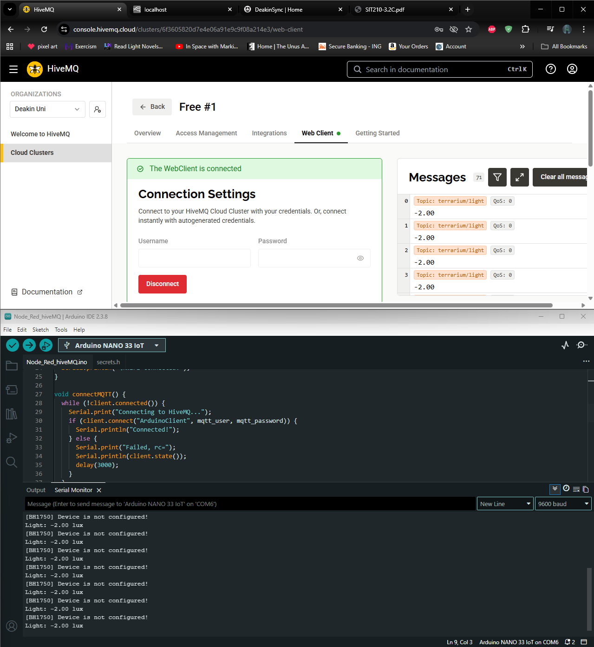

After the Arduino has started running the web client can be connected to start receiving messages.

testing:
We can test the light sensor using the serial monitor to confirm Wi-Fi connection and light readings. After Wi-Fi connection is established, we can test the MQTT broker by connecting to the web client and reading the received messages we expect to.
To verify full system functionality, we will conduct an initial function test by covering the Light sensor while monitoring the NODE-RED debug panel and Arduino serial monitor. This is to confirm the correct lux readings are being sent and only state the correct changes are being sent.

GitHub: https://github.com/charlieM044/SIT210

